

**Diploma in Software Engineering**

Final Report

Travel on Time Bus ticket booking system

Erandith Harshan Subasinghe

10602075

### Acknowledgement

I wish to express my heartfelt gratitude to the NIBM University and our lecturer and my supervisor Mr. Mr. Keshan Narangoda and all the other lecturers and the staff of NIBM University for the immense support rendered to make this project a huge success.

My special thank also goes to Devin Kanilka for the immeasurable support given in the process of implementing this project is mainly due to the knowledge that we have been gained throughout the last few months.

Last but not least my express my greatest thank to my dear family and friends without whose eager involvement this project would have been a more dream for me. The moral support and encouragement given to me by all the mentioned and not mentioned parties, in completing this project are highly appreciated.

### Abstract

Sri lanka is a still under developing country. Most of fields getting develop rapidly. Sri Lankan Government provides Free Health, Free education yet. But they charge for electricity, water, transport etc. Most of fields are not working efficiently. No proper plan and no proper management are the main reasons for that. As an under developing country, Sri Lankan’s using public transport methods to their day today transportations. But public transportation in Sri lanka is in bad situation.

Usually Trains, Buses, and taxies are using for traveling purpose in Sri lanka. By using this public transportation methods, passengers facing few troubles

* Lack of Buses / trains
* No specific timetable
* No specific price lists
* No method to find price earlier

These are only few of them. This situation is bad to every kind of passengers in Sri lanka. Because of this method only waste of time, money, labor. It is badly forcing to development of island. If develop transport filed, we must find solution for this problem.

As an undergraduate, I wanted to find a solution and fix this problem by using the things that we have already learnt inside the lecture halls. My main target was designing a perfectly working android application to resolve these problems and let passengers to travel comfortably.

This is the report of my application. There are few main categories in this report.

Basically introduction, identification and suitability of this application with modern problem and how it will useful to resolve this problem is describing by introduction chapter. Not only that functionalities, scope, and advantages and disadvantages of the project also included the introduction chapter. Business objectives, and project objectives are including the project background area. Use case diagram, activity diagram, class diagram, entity relationship diagram and functional requirements are including the Analysis and design.

Literary overview and comparison with current application you can find inside the literature review. Used technologies, design implementations and testing details contains in the implementation and testing area.

I used android studio 3.3 version to design this application. Database of this application was created using google firebase. This report is end with list of reference followed by all the relevant appendices.

### Contents

Acknowledgement .......................................................................................................................... 3 Abstract ........................................................................................................................................... 4

1. Introduction ........................................................................................................................... 11
   1. Problem Identification ................................................................................................... 11
   2. Online bus ticket booking survey ................................................................................... 13
   3. Scope of The Project ...................................................................................................... 14
   4. Functionalities ................................................................................................................ 15
   5. How It Differs from Other Systems ................................................................................ 15
   6. Advantages and Disadvantages of the System .............................................................. 16
2. Project background................................................................................................................ 17
   1. Exiting systems ..............................................................................................................19
   2. Objectives ...................................................................................................................... 21
      1. Business Objectives ................................................................................................ 21
      2. Project objectives .................................................................................................... 21
   3. Deliverables.................................................................................................................... 21
   4. report overview .............................................................................................................. 21
3. Analysis and design ............................................................................................................... 22
   1. Requirement Analysis..................................................................................................... 22
      1. Functional Requirements ........................................................................................ 22

1. User accounts ................................................................................................................. 22

This travel on time application provides both of passengers and owners of buses to create user accounts. Then can use their email addresses and their own password to login their user account. System not allows to create passwords less than 6 characters. theoretically it is

breakable password............................................................................................................... 22 2. forget password ............................................................................................................. 22 most of user’s common problem is forget user name and password. This system use email address as his user name. then it will be a reason to remember username of user. ........... 22 When user forgot his password, we have provided method to reset his password by using

his email address. .................................................................................................................. 22 3. Add bus ........................................................................................................................... 22

This function is inside the bus owner’s application. By using this function, owner can add details of his bus and register it to this application. Basically, he needs to add number of bus, route no, start location, end location, time, date and price of ticket etc. all data getting upload to real-time database of firebase. That data can access to passenger by passenger

application ............................................................................................................................. 22 4. About us ......................................................................................................................... 22

Most of applications use this function to add details of application developing company. So by using this function, user can get details of the company of application and main objectives

of this application. ................................................................................................................. 22 5. Contact us ....................................................................................................................... 22

Usually this part of application we use to contact company of application. Then user can contact developers of this application. I added my email address and mobile phone number

to this area. ............................................................................................................................ 22 6. Find bus .......................................................................................................................... 22

This feature is inside the passenger application only. By using this feature passenger can input his location and destination and find the most suitable bus within few taps . ............ 22

3.2 UML diagram .................................................................................................................. 24

3.2.1 ER diagram .............................................................................................................. 24

3.2.2 class diagram ........................................................................................................... 25

3.2.3 Activity diagram ...................................................................................................... 26

3.2.4 Use Case Diagram ................................................................................................... 31

1. Literature review ................................................................................................................ 32
   1. Literary overview of travel on time bus ticket booking application .............................. 32
   2. Technological justification............................................................................................. 34

Android studio IDE ................................................................................................................ 34

Firebase database .................................................................................................................. 35

Adobe XD ............................................................................................................................... 36

* 1. Comparison with related systems .................................................................................. 36

4.3 Why sri lanka need travel on time application .............................................................. 37

1. Method of approach .............................................................................................................. 39
2. Project Management ............................................................................................................. 40
   1. User Management .......................................................................................................... 40
   2. Time Management ......................................................................................................... 41
3. Initial User Interface Design .................................................................................................. 42
   1. Prototype Development ................................................................................................. 42
4. Project Stages ........................................................................................................................ 44
   1. Stage 1 ................................................................................................................................. 44
      1. Summary ....................................................................................................................... 44
      2. Deliverable .................................................................................................................... 44
   2. Stage 2 ................................................................................................................................. 44
      1. Summary ....................................................................................................................... 44
      2. Deliverables .................................................................................................................. 44
      3. Challenges and Accomplishment.................................................................................. 44
   3. Stage 3 ................................................................................................................................. 45
      1. Summary ....................................................................................................................... 45
      2. Deliverables .................................................................................................................. 45
   4. Stage 4 ................................................................................................................................. 45
      1. Summary ....................................................................................................................... 45
      2. Deliverables .................................................................................................................. 45
      3. Feedbacks from users ................................................................................................... 45
      4. Challenges and Accomplishments ................................................................................ 46
   5. Stage 5 ................................................................................................................................. 46
      1. Summary ....................................................................................................................... 46
      2. Deliverables .................................................................................................................. 46
   6. Stage 6 ................................................................................................................................. 46
      1. Summary ....................................................................................................................... 46
      2. Deliverables .................................................................................................................. 46
      3. Feedbacks from users ................................................................................................... 47
      4. Challenges and Accomplishments ................................................................................ 47
   7. Stage 7 ................................................................................................................................. 47
      1. Summary ....................................................................................................................... 47

8.7.2Deliverables ................................................................................................................... 47

8.7.3 Feedbacks from users ...................................................................................................... 47

8.7.3 Challenges and Accomplishments .................................................................................... 47

1. Testing ................................................................................................................................... 48
2. End-Project Report ............................................................................................................. 48
   1. Review of project objectives .......................................................................................... 48
   2. Communication and meetings ....................................................................................... 48
3. Project Post-Mortem ......................................................................................................... 49
   1. Achievements during the development......................................................................... 49
   2. Problems faced during the development ...................................................................... 49
   3. Future implementations ................................................................................................ 50
4. Conclusion .......................................................................................................................... 50
5. References ......................................................................................................................... 51 References .................................................................................................................................... 51
6. Appendices ......................................................................................................................... 52
   1. Installation and setting up project. ................................................................................ 52

Mobile application user manual ............................................................................................ 52

1. PID ...................................................................................................................................... 62
   * + 1. Introduction ....................................................................................................................... 62
       2. Business Case ..................................................................................................................... 62
   1. Business Needs ........................................................................................................... 62
   2. Business objectives .......................................................................................................... 63
      * 1. Project objectives ............................................................................................................... 64
        2. Initial scope ........................................................................................................................ 65
        3. Method of approach .......................................................................................................... 65
        4. Project plan ........................................................................................................................ 66
   3. Control plan ................................................................................................................ 67
   4. Communication plan .................................................................................................. 67
      * 1. Initial Risk List ..................................................................................................................... 67
        2. Initial Quality Plan .............................................................................................................. 68
        3. Appendix ............................................................................................................................ 70
2. Interim Report 1 ................................................................................................................. 71
   * + 1. Introduction.................................................................................................................... 71
       2. Business Case ................................................................................................................. 71

11.1 Business Needs ........................................................................................................... 71

2.2 Business objectives .......................................................................................................... 72

* + - 1. Project objectives ........................................................................................................... 73
      2. Methodology .................................................................................................................. 73
      3. Limitation of the Project ................................................................................................ 73
      4. Future implementation .................................................................................................. 73
      5. Literature Review ........................................................................................................... 74
      6. Risks ................................................................................................................................ 75
      7. Task undertaken ............................................................................................................. 76

1. Interim Reports 2 ............................................................................................................... 77

1.0. Introduction ....................................................................................................................... 77

2.0. Project objectives ............................................................................................................... 78

3.0. ER diagram ......................................................................................................................... 78

4.0. User case diagram .............................................................................................................. 79

5.0. Project plan (Draft table) ................................................................................................... 80

6.0. A draft Table of Contents for the final report.................................................................... 81

7.0. Conclusion .......................................................................................................................... 82

Figure 1 ER diagram ..................................................................................................................... 24

Figure 2 class diagram ................................................................................................................... 25

Figure 3 activity/sign up ................................................................................................................ 27

Figure 4 activity/login ................................................................................................................... 28

Figure 5 activity/forgot pw ........................................................................................................... 29

Figure 6 activity / add bus ............................................................................................................. 29

Figure 7 activity / find bus ............................................................................................................ 30

Figure 8 user case ......................................................................................................................... 31

Figure 9 booking rate .................................................................................................................... 33

Figure 10 firebase ......................................................................................................................... 35

Figure 11 Sprint (Rad and Turley, 2015). ...................................................................................... 39

Figure 12 proto type ..................................................................................................................... 43

Figure 13 login............................................................................................................................... 53

Figure 14 home ............................................................................................................................. 55

Figure 15 add data ........................................................................................................................ 56

Figure 18 add location .................................................................................................................. 57

Figure 19 retrieve data .................................................................................................................. 58

Figure 20 about us ........................................................................................................................ 59

Figure 21 contact us ...................................................................................................................... 60 Figure 22 change password .......................................................................................................... 61

#### 1. Introduction

Sri Lankans use public transportation methods to their day today traveling requirements. But there is no any plan or management method for this purpose. Then passengers and entire transport field facing huge trouble. It is very bad for development of Sri Lanka and entire island.

**Travel on Time** is a better solution for this problem. This application designed based on well planned research. Huge collection of data around the island. Every kind of buses, every kind of passengers and passenger requirements are considering for design this application.

By using this application passenger can find the most suitable bus easily. Then he/she can book a ticket and get to the destination without any trouble. This is mainly design for long distance travelers. They can travel by same bus their whole distance.

##### 1.1 Problem Identification

Sri lanka is an under developing country. There lots of troubles with few kinds of fields. I planned to design this application to resolve few problems in the transport method. Mainly we can divide buses in Sri Lanka into 2 categories based on ownership of buses.

* Sri Lanka Travelling Busses. (owned by government)
* Other Buses. (Owned by Non-government companies)

Mainly we can see few problems in bus traveling. We can list down them and details below.

**1. Lack of buses.**

We can see number of buses in town area and everywhere. Most of them are private buses. But in outstation areas we can’t find buses easily. If someone want to travel to above area by a bus, it is very difficult task. Because of lack of buses. Often the reason for that is condition of the road. Then owners of buses don’t like to get route permit of that route. Due to that reason there are more crowd inside a one bus. It is a very difficult to travel by bus.

##### 2. No specific time table for buses

Every bus wants to have a route permit and time table. But modern bus drivers don’t care about the time table. Sometimes there are few buses in same route in same time. And sometimes there no any bus for a long time. It is huge problems to bus travelers.

##### 3. No specific price of ticket

Every service needs to have a specific price. But modern bus conductors don’t care about it. They charge huge prices for a ticket. It is bad for public transport. Passengers need a ticket for a specific price. Then conductor can’t charge illegal price for a ticket. Bus conductors charge more cost from foreign passengers. It is bad for tourism in entire sri lanka.

##### 4. No set of rules for bus drivers

This is a very common situation in sri lanka. In modern buses not follow traffic rules. Over speed limits, not caring about passengers and pedestrians, color lights etc. due to this reason there are more accidents happening every day in sri lanka. Most of bus drivers drive their vehicle carelessly. It is a very dangerous situation. It’s a kind of road violence. Sometimes police officers not taking actions against them. It’s a very sad situation.

**5. Low quality service.**

Every service must be quality. Modern bus services are in very low quality level. Conductor never gives remaining change money. Not caring about passengers. No specially attention on disabled persons, pregnant moms. Passenger need respect and protection during his traveling period. But most of modern conductors not respecting to others and not doing their job properly.

###### 1.2 Online bus ticket booking survey

* Do you book bus tickets online?
  + 1. Yes
    2. No

* How often do you book bus ticket?
  + 1. Daily
    2. Weekly
    3. Monthly

* Usually where are you going using bus?

………………………………………………………………………………..

………………………………………………………………………………..

* How you book a bus ticket
  1. Over mobile application
  2. Over the web browser
  3. Other

* What is the approximately money you spend on booking a bus ticket per time (LKR)
  1. < 100 ii. < 200 iii. < 500 iv. More than 1000

* What are the experiences about bus ticket booking systems?

…………………………………………………………………………………………………..

…………………………………………………………………………………………………..

Name ………………………………………………………………….

Mobile number …………………………………………………………

###### 1.3 Scope of The Project

**Travel on Time** is an application that passenger can find the most suitable bus for his traveling purpose. Passenger can add his current location and destination to this application and find most suitable bus. Then he can book a ticket for that specific bus. Passenger can pay an advance to the bus and book a ticket permanently.

Bus owner has another application. He can login to account and add details of bus. As an example, Bus No, start location, end location, price of ticket, date and time etc. then he can add that data into firebase database. Passenger can access that data through his **Travel on time** application. Basically, this application design to find a bus easily and quickly to a long-distance traveler. when turn into the side of bus owner, he can find passenger before start the trip. And he can get prepayment from the passenger.

If passenger had a better bus traveling experience, he can help to owner and to the bus company by rating their service.

###### 1.4 Functionalities

This application is mainly designed for passengers and owners of buses. Both of them have few tasks to do by using this application.

**From passenger’s aspect,**

* Log in to application.
* Add your current location • Add location you wish to go.
* Select a suitable bus.
* Book a ticket
* Pay an advance payment

**From owner of buses’ aspect,**

* Log in to application
* Add details of your buses
* Add data to database
* Confirm or reject booking of passenger
* Receive payment

###### 1.5 How It Differs from Other Systems

Most of bus booking systems are web applications in sri lanka. When passenger travelling, browse a web page and searching for a bus is very difficult and not so user friendly. Less than 5 android applications are available now. But most them are not working properly. I found my own experience and by using reviews of those applications. Those application no function to login or log out. It is a problem for the application users. Those applications can’t create accounts. Then passengers can’t rate bus services. Not only that, current application can’t pay an advance to the bus for the ticket booking.

In Travel On Time application I have provide facilities to create an account. Then users can create a user account and login/log out using that account. Then they can rate bus services by using their user accounts. It is very useful to new user application users. users can pay an advance by using this “travel on time” application to bus owner. It is very useful for owners of buses.

Sometimes passengers can book a bus and absence to the specific date. It is a huge fail of current systems. But Travel On time application there is an option to pay advance for the trip. Then passengers can’t cheat or they can’t book ticket and get absent.

###### 1.6 Advantages and Disadvantages of the System

As we know every application has advantages and disadvantages. If one of their advantages area more than disadvantages, we can decide it as a good application. I tried to make a better application.

##### Advantages of the travel on time application

* by using this application passenger can find most suitable bus quickly. There are various kind of buses. During them passenger can find most suitable to him and to his pocket.
* this is an application. Then booking a ticket is very easily. Passenger can select bus and book a bus without browsing a web page. It is very easy for person who has not cleverer literacy of technology.
* It saves your money and time that you spend for travel. You can find the time of bus and can be there on time.
* When you travel a long distance, you can find a bus to travel entire distance. You can find long distance buses. They faster than others.
* By using pre booking bus, passenger can travel without any risk about his seat. Passenger can travel with free mind.
* Passenger can get a perfect service from bus for his payment. There is a price list for the tickets. Then conductors can’t cheat anymore.
* Passenger can rate the service of bus and let others know the service of bus. Other side it will be a force to a quality service.
* New users of application can focus on the rate on buses and select most efficient bus service.
* I have already designed two applications for passengers and for owners of buses. Then if someone want to add a bus for this application, he must install bus owners application **Disadvantages of the travel on time application**
* this application basically designed for long distance travelers. Then if someone want use this application for a short distance, it is really not useful for that passenger. If he booked bus for a short distance, he needs to pay whole distance price.

#### 2. Project background

Mainly we can divide Sri lanka traveling buses into 2 parts based on ownership. Government buses and private buses. Those two types of buses provide good service to sri lanka transportation field. Most of people traveling by using these two types of buses. Because bus service has spread everywhere in the island. Not only that this cheap service. So, bus services are more popular than other traveling methods. Government buses and private buses are earning money from this task. Private section can earn money from this task. Private companies doing this as a business.

When everything become a business, quality is getting low. When private buses getting increase, drivers and conductors are trying to collect more passengers and more money. Then service become a competition. It is badly force whole transport system. Transport system getting out of control. It is a big issue. This is not only about private section. Government buses also in same trouble. This bus services must need proper management. Then we can hope a proper bus service in sri lanka. Buses must start and end their trip on time. Then passengers can select specific bus by following time table. By good management passengers can get maximum efficient from the buses.

We can mainly divide buses into two parts based on distance.

* Long distance buses
* Short distance buses

long distance buses are not stopping every bus stop. They stop only main bus stops. And they faster than other buses. most of passengers are waiting for these buses. because it is easy to travel and it save their time. After 2009 year, long of distance of the routes were increased. Tangalle – Jaffna, matara – Jaffna Tangalle – mulativu route permits were sold than past. It is a huge turning point of bus culture of sri lanka. after 30 years’ war, now we can travel every area in island by bus. Most of long-distance buses drive by both of driver and conductor. Because they have to travel more than 400km per one day. Those buses traveling more than 8/9 hours. It is dangerous. Then they use conductor as core driver in out station areas. Most of passengers are waiting for same bus for traveling. Bus drivers also waiting for that specific passengers. In sri lanka people use long distance buses as a courier service too. They load their items into cabin of bus and bus driver drop that items in correct location. It is an extra advantage of bus and extra chance to earn money.

There are few troubles with long distance buses too. These are limited bus stops. Some people get into these buses to travel quickly but for small distance. Then both of driver and passenger getting into trouble. Most of these buses are always full with passengers. It is an extra risk for this speed buses. long distance buses face to some serious problems with wild animals. These buses face this trouble in the out-station areas. most of cows and wild animals comes to roads and around the roads at night. Most of elephants cross the roads. Sometimes elephants attack to buses. it is very dangerous situation. As a solution for that bus drivers use “ali horn” by using ali horn elephants move away from the road. Most of these buses breaking traffic rules and drive very fast. It also a risky to everyone on the road.

Short distance buses also doing a huge part of transport task in island. Most of buses in sri lanka including to this part. Most of short distance buses are slower than long distance buses. those buses stop every bus stop and collecting passengers. So some passengers don’t like to travel with them. It takes more time to travel. But short distance buses are more safe than long distance. Because those buses go slowly and no more passengers than other buses.

When we talking about bus traveling, we can divide buses into 4 parts based on facilities of the buses.

* Normal buses
* Semi luxury buses
* Luxury buses
* Super luxury buses

Most of buses in sri lanka are normal buses. most of those buses are used for middle distance rides. Those buses stop everywhere. Ticket price is very low. No much comfortable inside the bus. No arm rests. No head rests. No entertain methods. No passenger limit, No entertaining methods. Due to this reason, most of passengers don’t like to travel in these buses. these buses really no comfortable.

Semi luxury buses are using for long distance. Theoretically semi luxury buses have limit of passengers. Semi luxury buses allowed to transport passenger count equal to sheets. But in sri lanka that rule is not working properly. Semi luxury buses are carrying passengers more than sheets. It is a bad situation. Semi luxury buses have arm rest, head rest, curtains and good entertainment systems. Most of semi luxury buses are used to long distance trips. Those buses earn much money than normal buses. most of semi luxury buses are stops limited bus stops. And they faster than others.

Most of luxury buses are traveling under the highway bus services. Those buses are so different than both of above buses. most of these buses are intercity buses. then they are not stopping bus stops during the trip. Driver and conductor must wear formal suits. They provide good and respectable service for customers. All of these buses are fully air conditioned. You can adjust air condition situation. Fully functional adjustable sheets with arm rests, headrests are available. Price of a ticket is higher than semi luxury buses and normal buses. they provide good entertainment system and huge trunk compartment. Most of these buses are long distance buses. every express way bus are luxury buses.

Super luxury buses are rare in sri lanka. These buses are providing best service to passengers. Adjustable sheets, air condition, head rests, arm rests, separate entertainment systems for everyone. Very good and respectable service. These buses are the most speed buses in sri lanka. They no stop during the travel time.

All of these buses provide priceless service for passengers. There are lots of rules and regulations around this service. Every bus must have a route permit. Every passenger traveling bus wants to ride on their time slot. Speed limits, passenger limits are available. Horn legality, decoration legality, entertainment legality etc. rules are already exits. Most of these rules are working. But some rules not got power yet.

##### 2.1 Exiting systems

Find a suitable bus for travel was a huge problem for a long time. Few companies tried to find a method earlier than me. Government of sri lanka used an automatic ticket machine for conductors. Most of conductors use this machine for ticketing purpose. It is a small solution for illegal prices charge for bus tickets. This machine use most of government buses and private buses. it is good for public transportation. That machines already designed for issue fare price for a ticket.

There are few companies that allows to book a ticket of buses modern. As an example, busseat.lk is a company that can book a sheet from a bus. That company use a web page to book seat of buses. they have nice looking web page. That web site is very user friendly and easy to use. Everyone can find a bus using this web application. Owners of buses can enter all details for this application. Name of bus, number of bus, route number, start location, end location, start time, end time, date, features, price of ticket, available seats times that bus arrival to main towns and type of bus etc. it is good application. There are few issues too. Main issue is it is a web application. When someone outdoor, browsing for a bus seat and booking it is very difficult. If someone with waiting for a bus with bags or small child, it is very difficult to use a mobile phone browser, search for the web application and book a seat. They need to develop an android application for this task. Then passengers can use that specific application for bus ticket booking task. There is a one more issue of this application. There are no much buses registered in this application. Only very small amount of buses has registered. Then passenger can’t find buses for long distances.

There is a one company named busbooking.lk. it is a very well managed web application. Everyone who can use a mobile phone, can book a ticket by using this application. Passenger has to select his location, destination and pic the date for search a bus. Application has provided name of bus, model of bus, route no, start location, end location, time duration, class of bus, price of ticket, and option to select seat of bus. It is a well-managed application. They have provided a direct chat room to chat with admin to passenger. It is a unique feature for a bus ticket booking system. Not only that they are using an android application for this bus ticket booking task too. We can use both of mobile application and web application for book a bus ticket. They send an email for the reservation. We can pay directly for bus and reserve a seat from this application. It is a very good method for payment.

Busticket.lk is a one of bus ticket booking web application available in sri lanka. It also a nice looking and well planned and well managed application. It is too different with others with return date field. Passenger can book a bus to up and down of the trip using this application in one time. It is unique for this kind of applications. That application has few troubles with lack of registered buses. that is not good for outstations travelers. They haven’t any mobile application for book a bus ticket. It the main problem with this application.

These are few of applications among bus ticket booking applications. I can get idea from this few of applications how I want to develop my application.

##### 2.2 Objectives

###### 2.2.1 Business Objectives

* Save time
* Save money
* Find a bus easier
* Find ticket price, functions, other details earlier
* Bus owners can find passengers easily
* Can get advance from passenger

###### 2.2.2 Project objectives

* Provide well designed 2 applications to users

Reduce money wastage of both part of users

* Reduce illegal buses from the route
* Manage bus transport system

##### 2.3 Deliverables

The final deliverable for this project got 2 separate mobile android applications for passengers and owner of buses with full functionalities of booking bus tickets through the internet.

##### 2.4 report overview

The report provides and describes the implementation of the mobile application and the related planning, management. Starts with the literature review of the project by explaining the theories and technologies used during the software development circle. After that will be highlighting the method of approach which was used throughout the development of Travel on Time application. Also describes the project management approach which used. Also, the system requirements will be included

#### 3. Analysis and design

##### 3.1 Requirement Analysis

###### 3.1.1 Functional Requirements

1. User accounts

This travel on time application provides both of passengers and owners of buses to create user accounts. Then can use their email addresses and their own password to login their user account. System not allows to create passwords less than 6 characters. theoretically it is breakable password.

1. forget password most of user’s common problem is forget user name and password. This system use email address as his user name. then it will be a reason to remember username of user.

When user forgot his password, we have provided method to reset his password by using his email address.

1. Add bus

This function is inside the bus owner’s application. By using this function, owner can add details of his bus and register it to this application. Basically, he needs to add number of bus, route no, start location, end location, time, date and price of ticket etc. all data getting upload to real-time database of firebase. That data can access to passenger by passenger application

1. About us

Most of applications use this function to add details of application developing company. So by using this function, user can get details of the company of application and main objectives of this application.

1. Contact us

Usually this part of application we use to contact company of application. Then user can contact developers of this application. I added my email address and mobile phone number to this area.

1. Find bus

This feature is inside the passenger application only. By using this feature passenger can input his location and destination and find the most suitable bus within few taps.

###### 3.1.2 Nonfunctional Requirements

1. Availability:

This application is available to access any time and get services with maximum number of users.

1. Reliability:

This application is an error free and working according to the specification mentioned.

1. Security:

This application provides create individual user accounts to users. user can use their email address and their password for user account. If someone forgot his user password, he can reset his password by using his email address

1. Accuracy:

This application depends on real time database. Passenger can see every information that owner of bus adds. Owner of bus can’t keep empty fields of bus. Then passenger can find most suitable bus.

**3.2 UML diagram**

###### 3.2.1 ER diagram

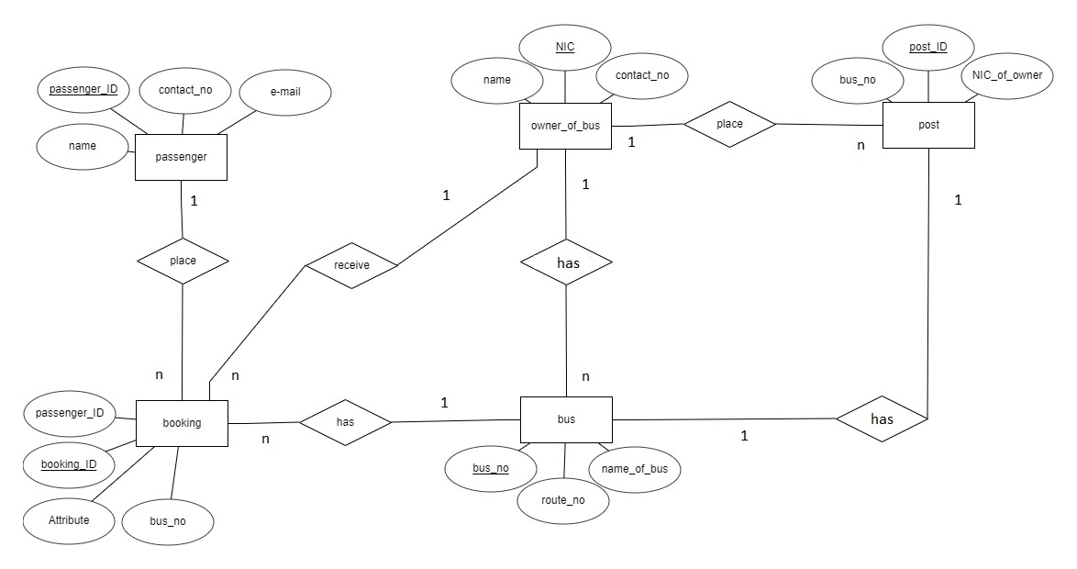

*Figure 1 ER diagram*

###### 3.2.2 class diagram

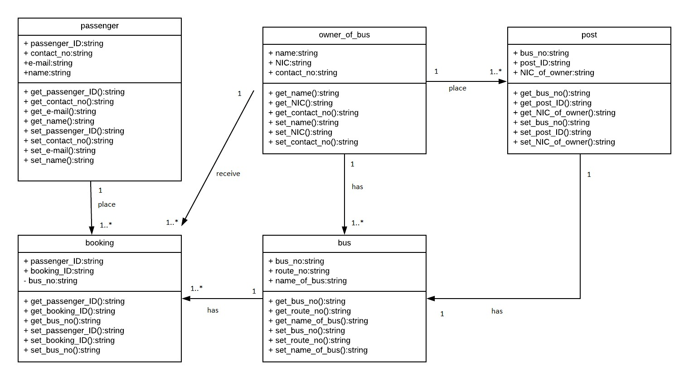

*Figure 2 class diagram*

###### 3.2.3 Activity diagram

Related to this application I designed a activity diagram for few process of this application.

* User sign up
* Login
* Forgot password
* Add bus
* Find bus

##### User sign up

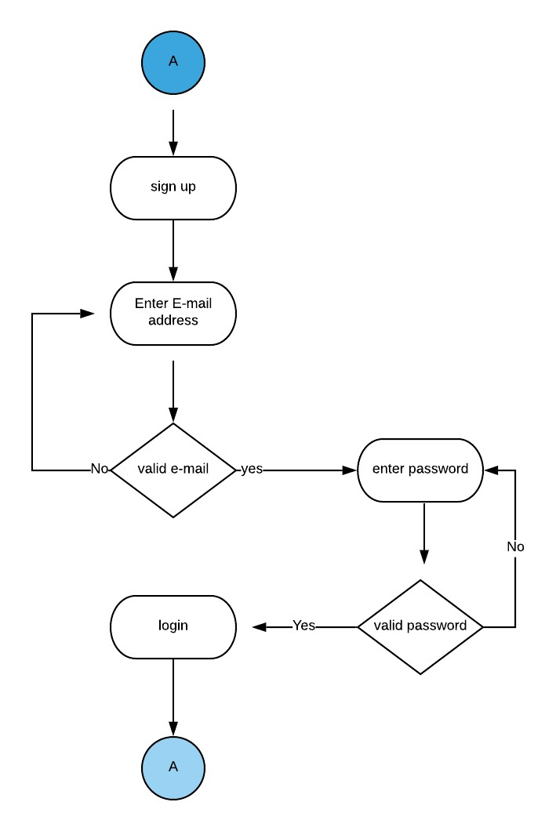

*Figure 3 activity/sign up*

##### Login

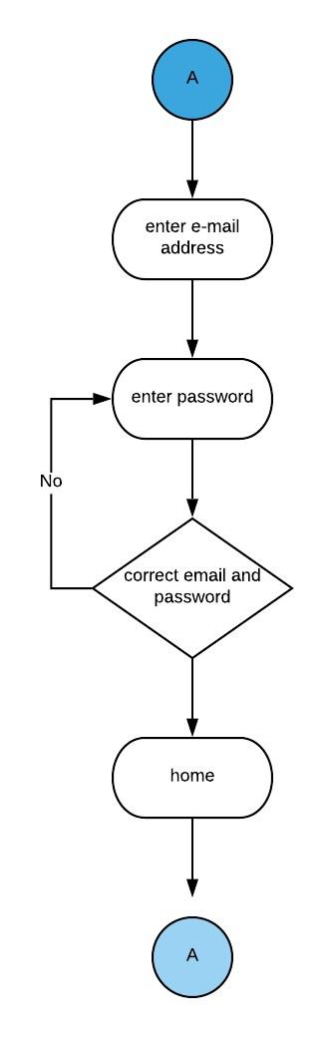

*Figure 4 activity/login*

##### Forgot password

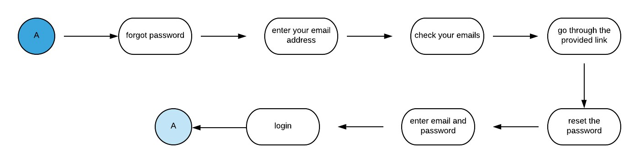

*Figure 5 activity/forgot pw*

##### Add bus

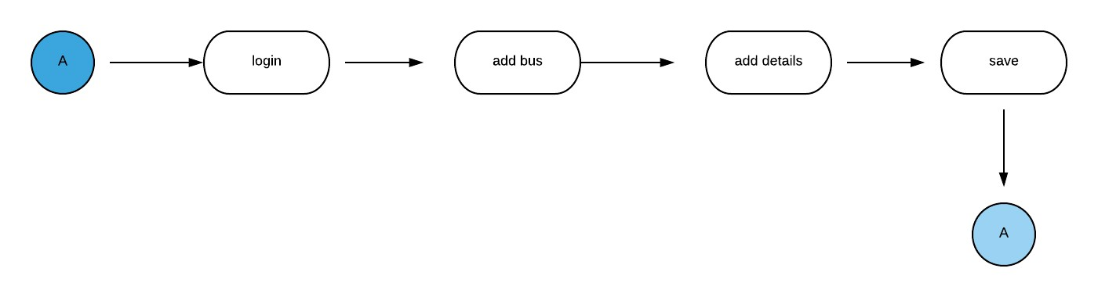

*Figure 6 activity / add bus*

##### Find bus

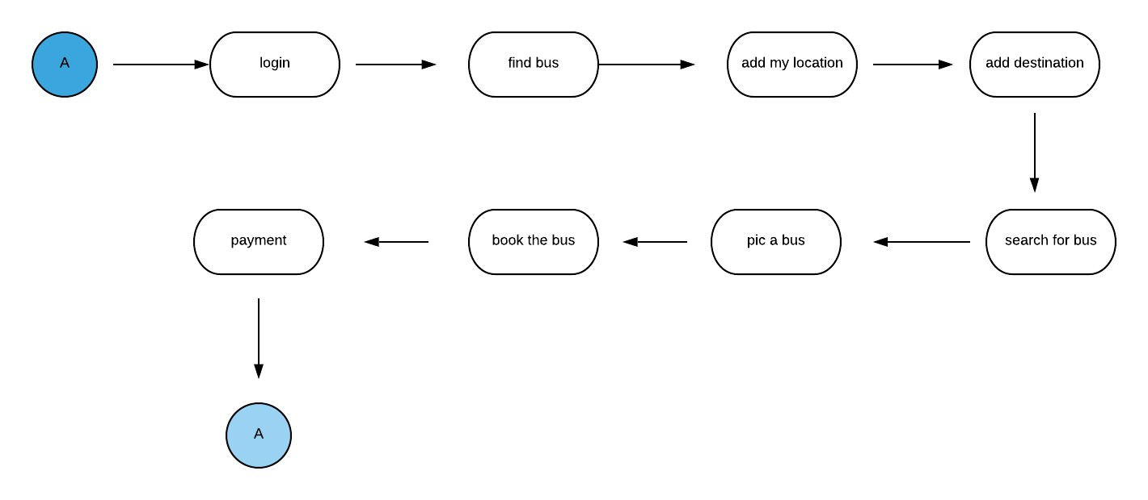

*Figure 7 activity / find bus*

###### 3.2.4 Use Case Diagram

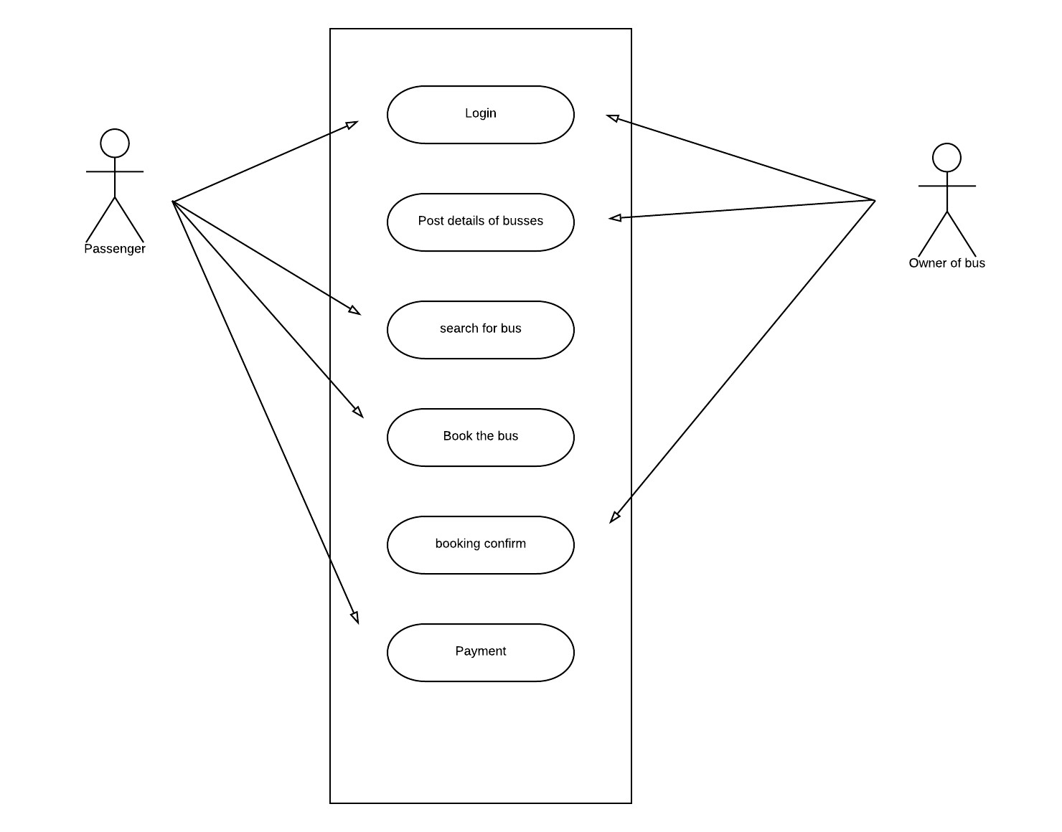

*Figure 8 user case*

#### 4. Literature review

##### 4.1 Literary overview of travel on time bus ticket booking application

As an under developing country, sri Lankans use public transportation methods for their day today requirements. Most of people use buses as their public transportation method.

In sri lanka we can see lots of buses providing their services to transportation task. Most of them are private buses. considerable amount of government buses also on duty for the public service. Government paying for the conductors, drivers and repairs of buses through the depots. Government earns from this bus services. When we turn into private section, owner of bus pays for the drivers, conductors and for other repairs and for the route permit. There are lots of buses in town areas. but there is no enough bus amount in the outstation areas. it is a huge issue of sri lanka traveling purpose.

Every bus wants to have a route permit and time table. But modern bus drivers don’t care about the time table. Sometimes there are few buses in same route in same time. And sometimes there no any bus for a long time. It is huge problems to bus travelers. When two or more buses are running on the same time in on route, it makes a competition between those buses. it is dangerous for bus service, passengers and pedestrians too.

Every service needs to have a specific price. But modern bus conductors don’t care about it. They charge huge prices for a ticket. It is bad for public transport. Passengers need a ticket for a specific price. Then conductor can’t charge illegal price for a ticket. Bus conductors charge more cost from foreign passengers. It is bad for tourism in entire sri lanka.

Because of these reasons various kind of groups trying new functions for fix these major issues. Online bus ticket booking, online bus seat booking applications are the most efficient methods. few of online ticket booking systems are available now a day. There are web applications to book tickets. Most of these systems are web applications. Few numbers of systems are available with mobile applications.

Most of web applications are hard to use in public place. Because of in mobile place we can’t spent much time to brows for a web application. It takes much time. Then most suitable method for bus ticket booking system is create a mobile phone application. Because sri Lankans use mobile phones more than whole population of country. We can increase number of users of system by creating a mobile phone application. By using mobile phone application passenger can access application and select a bus easily.

Most of children use mobile phones since very younger age. Then most of people can handle a mobile application without big issue. Next point is select operating system for the application. There are various kinds mobile phones with various kinds of operating systems. Android, windows, windroid, iOS, symbiont are the few of them. Most of mobile phone user’s area android users. because of this situation creating an android application is the best solution. By creating android application, we can spread our application easily.

(Andolasoft, 2009)

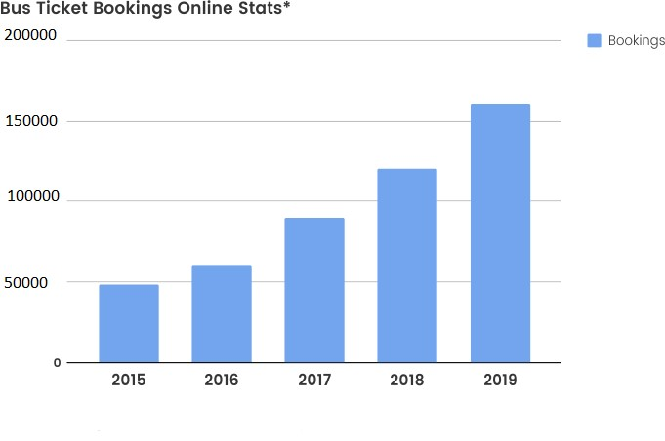

*Figure 9 booking rate*

By analyzing this graph, we can see rapidly developing bus ticket booking process. People using these systems and making their works easier.

**4.2 Technological justification**

##### Android studio IDE

(google, 2011)

As an IDE then, Android Studio's job is to provide the interface for you to create your apps and to handle much of the complicated file-management behind the scenes. The programming language you will be using is either Java or Kotlin. If you choose Java, this will be installed separately on your machine. (Mullis, 2017)

Android Studio IDE was chosen because of the benefits that presented to the developer. (Mehul, 2015) When the Google announced Android Studios in 2013, it paves the way to make android applications with more efficiency. Gradle Integration, User Interface, System stability and Drag & Drop options make Android Studio very comfortable while developing a system. (Tran, 2018)

**Firebase database**

(firebase, 2011)

Google Firebase was announced in 2016. As one option it has Real-time Database which is cloud hosted NoSQL database (data is stored in documents rather than tables) that let user to store and sync between users in real-time. This real-time database is one massive JSON object so developers can manage it in real-time. (Ants, 2017)

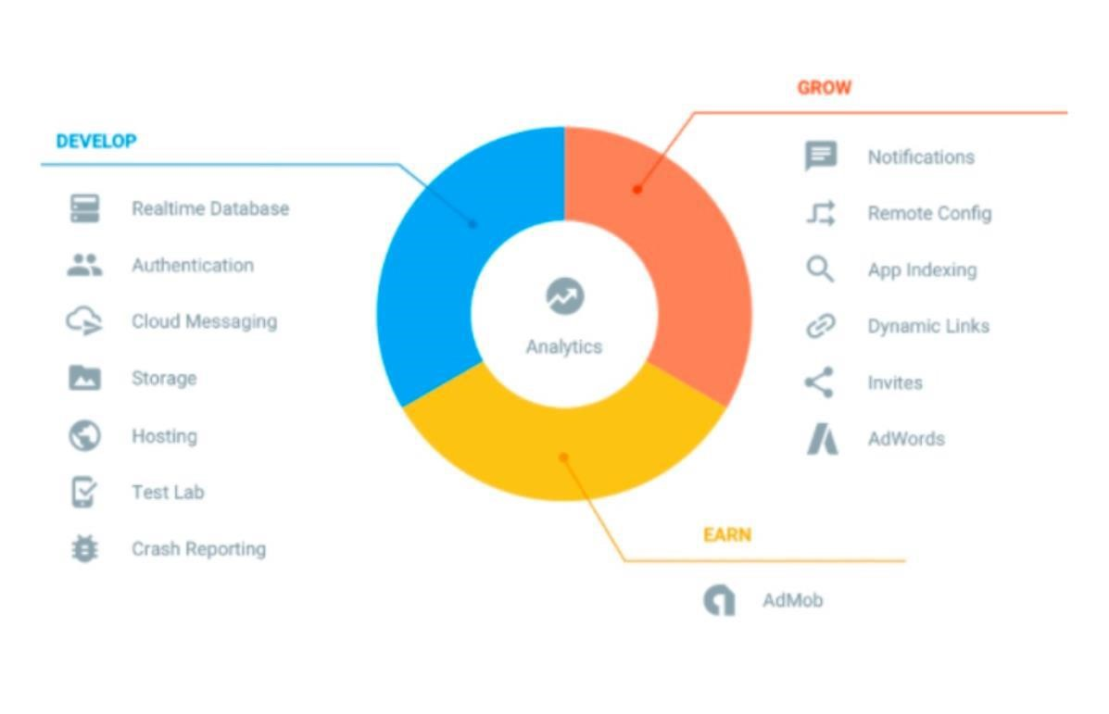

*Figure 10 firebase*

When focusing on Google FireBase queries in the database are focused on a collection of documents, due to that it’s fast and efficient. It’s more difficult to write complex queries in FireBase database than in the SQL. However, I used OBJGen (Systems, 2019) to generate live JSON codes which makes that process easier than the regular way. FireBase has many and more features with it (S, 2017). Such as client-server real-time synchronization, Firebase admin SDK and hosting services also.

##### Adobe XD

(XD, 2017)

Adobe XD is all in one UI/UX solution for design, prototype and sharing of mobile applications, web sites. Adobe XD can create prototypes and wireframes with ease in all the platforms including Windows, Mac OS, IOS and Android.

Once (Johansson, 2019) said that “Prototyping is nice and easy, just link screens together in a matter of clicks. Switch back and forth between design and prototyping seamlessly. Update the design and watch it change live within the prototype. Pretty cool! You can also live preview changes directly on your phone if you are designing a mobile app.”

###### 4.3 Comparison with related systems

I did a research about modern main bus ticket booking systems. Most of them are web applications. I could find advantages, disadvantages and failures of those applications. I wanted to list down all information of those applications and compare them all with my system. This all systems are sri lankan applications. All of them are designed by professional developers.

(BusSeat.lk, 2014)is a company that can book a sheet from a bus. That company use a web page to book seat of buses. they have nice looking web page. That web site is very user friendly and easy to use. Everyone can find a bus using this web application. Owners of buses can enter all details for this application. Name of bus, number of bus, route number, start location, end location, start time, end time, date, features, price of ticket, available seats times that bus arrival to main towns and type of bus etc. it is good application. There are few issues too. Main issue is it is a web application. When someone outdoor, browsing for a bus seat and booking it is very difficult. If someone with waiting for a bus with bags or small child, it is very difficult to use a mobile phone browser, search for the web application and book a seat. They need to develop an android application for this task. Then passengers can use that specific application for bus ticket booking task. There is a one more issue of this application. There are no much buses registered in this application. Only very small amount of buses has registered. Then passenger can’t find buses for long distances.

There is a one company named (BusBooking.lk, 2012). it is a very well managed web application. Everyone who can use a mobile phone, can book a ticket by using this application. Passenger has to select his location, destination and pic the date for search a bus. Application has provided name of bus, model of bus, route no, start location, end location, time duration, class of bus, price of ticket, and option to select seat of bus. It is a well-managed application. They have provided a direct chat room to chat with admin to passenger. It is a unique feature for a bus ticket booking system. Not only that they are using an android application for this bus ticket booking task too. We can use both of mobile application and web application for book a bus ticket. They send an email for the reservation. We can pay directly for bus and reserve a seat from this application. It is a very good method for payment.

Busticket.lk (Ltd, 2010) is a one of bus ticket booking web application available in sri lanka. It also a nice looking and well planned and well managed application. It is too different with others with return date field. Passenger can book a bus to up and down of the trip using this application in one time. It is unique for this kind of applications. That application has few troubles with lack of registered buses. that is not good for outstations travelers. They haven’t any mobile application for book a bus ticket. It the main problem with this application.

Travel on time application is a mobile android application. It is a well-managed application too. Basically, this application contains two applications. Application of admin and application of passenger. We can get owner of bus as admin. Owner of bus has to go through the admin application and log into application and add details of bus. And other application can use to the passenger. Passenger can log into this application by using his user name and password. Then he can select his start location and destination and search for the most suitable bus. By using this application user can find every information of bus. He can choose the class of bus too.

###### 4.3 Why sri lanka need travel on time application

Most of sri lankan use buses as their public transportation method. every one need buses to travel somewhere. Buses spread everywhere. We can find buses from every area of sri lanka. Bus traveling is the easiest method to travel on public transportation. When we compare with other transport method, bus traveling is the easiest, most efficient and most money saving method. but when we using bus traveling, we have to face some issues we need to fix those troubles or by pass them all. We need this travel on time application for find solutions for those troubles.

We can see number of buses in town area and everywhere. Most of them are private buses. But in outstation areas we can’t find buses easily. If someone want to travel to above area by a bus, it is very difficult task. Because of lack of buses. Often the reason for that is condition of the road. Then owners of buses don’t like to get route permit of that route. Due to that reason there are more crowd inside a one bus. It is a very difficult to travel by bus. By using this travel on time application, owners of bus can include buses to route of low amount buses. then this application will help for lack of buses. Not only that passenger can arrange his trip according to bus schedule by using this application. Then he can save his money and time. Not only that he can get use of this application efficiently.

Every bus wants to have a route permit and time table. But modern bus drivers don’t care about the time table. Sometimes there are few buses in same route in same time. And sometimes there no any bus for a long time. It is huge problems to bus travelers. When using this application need to leave and arrive on time. They have to work on time. If bus not working on time, passengers can report this bus. If bus working properly, working on time, offer respectable service passenger can rate the bus. New passengers can check the rate of buses and decide to book the bus.

Every service needs to have a specific price. But modern bus conductors don’t care about it. They charge huge prices for a ticket. It is bad for public transport. Passengers need a ticket for a specific price. Then conductor can’t charge illegal price for a ticket. Bus conductors charge more cost from foreign passengers. It is bad for tourism in entire sri lanka. Conductor not giving balance money too. it is a very bad situation. But when we use this application, passenger can know the price of ticket before he gets into the bus. Then he can decide selection of bus. And conductor can’t ask for illegal prices for thickets. Passenger can only pay the price on the application.

This is a very common situation in sri lanka. In modern buses not follow traffic rules. Over speed limits, not caring about passengers and pedestrians, color lights etc. due to this reason there are more accidents happening every day in sri lanka. Most of bus drivers drive their vehicle carelessly. It is a very dangerous situation. It’s a kind of road violence. Sometimes police officers not taking actions against them. It’s a very sad situation. When passenger use this application, he can prevent this kind of problems. He can select more rated bus for his service. More rated buses are providing their services properly. Not only that when you used the bus if you satisfied with the bus service, you can rate the bus as a good bus. Then other passenger also can select this bus for a good service. If you not satisfied with the service you can report the bus to admin. This rating method makes bus service better. Otherwise passenger will not get into that bus anymore.

Every service must be quality. Modern bus services are in very low-quality level. Conductor never gives remaining change money. Not caring about passengers. No specially attention on disabled persons, pregnant moms. Passenger need respect and protection during his traveling period. But most of modern conductors not respecting to others and not doing their job properly. this situation also can control by using this travel on time application. Passenger can select more rated bus for his service. If one of bus not provide their service properly, you can report the bus and let others know. if you satisfied with the bus service, you can rate the bus as a good bus. Then other passenger also can select this bus for a good service. This rating method makes bus service better. Otherwise passenger will not get into that bus anymore.

#### 5. Method of approach

Travel on time mobile application was developed using agile (Anon.,2019) approach. The agile process states that interaction, working software and responding to change hold more value than processes, documentation and following a plan. This process produces a flexible method of software development which is more accommodating to the ever-changing requirements of a software project.

SCRUM (Anon.,2018) is one form of agile framework. Scrum framework is made up with five main events. Sprint planning, daily scrum, sprint review, sprint retrospective and sprint.

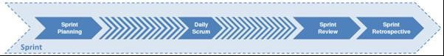

*Figure 11 Sprint (Rad and Turley, 2015).*

Within each sprint, all the product items were added in order to priorities along with the aim of completing each item by the end of the current sprint. If any task has not been completed in relevant sprint, are transferred into the next sprint. This method has added benefit of producing a reliable product in the end of each stage of sprint.

#### 6. Project Management

Software project management is defined as the application of good software management principles as well as software engineering principles. The project should deliver around estimated cost, with estimated time, and with good product quality. Developer should follow up with these steps to ensure that the project has a successful ending.

While developing Android Eat It, project management principles and development lifecycle of techniques were followed in order to make successful project as below.

##### 6.1 Supervisor Meetings

Supervisor meetings were arranged as necessary for the majority of the project towards the project completion.

Meeting minutes were also produced after each meeting along with the highlighting what was discussed in each meeting and what should be completed before next meeting. These meetings were very beneficial, those feedback from an experienced professional was priceless. Information gained through the meetings helped to create more creative and polished system. Scanned images of meeting minutes can be viewed on appendix

##### 6.2 User Management

Good project management skills were needed for the management of users in user testing activities. It was essentials that the user testing was carried out in a professional and courteous manner, so that the participants were feeling positive after the experience and so that useful data could be obtained.

#### 7. Initial User Interface Design

Initial user interface designs were created using Adobe XD (Adobe, 2019) to draw wireframe designs which is an easy way to create simple and effective prototypes and wireframe designs. The wireframe designs were great opportunity to design the exact functions of the system. And also, they were used as inspiration for the design of the prototype systems described below as well as the initial stage of product design.

##### 7.1 Prototype Development

Prototype is a major thing to gain the maximum rate of successful project. Prototype is essential to create successful software and successful user experience that may affect to the final product. User experience is a main thing when which should focus when creating a new system. If user is not familiar with the new system or user cannot adhere to the new system, that system is not succeeded. Don (Norman & Nielsen, 2017) mention that “When creating a new system developer should always concern about the user experience”.

Before developing the final product, a prototype was created in order to provide a proof of concepts and to create more successful deliverable. The full prototype report, which will provide a detailed information in the development of prototypes can be viewed in appendix.

The report confirms that the Android Application prototype would be used in the final product. It was discovered that MySQL database has server down errors sometimes. To avoid such circumstances Google FireBase was used as the database. It has more flexibility in that area and easier to manage. But it added more complexity to the development when dealing with the FireBase.

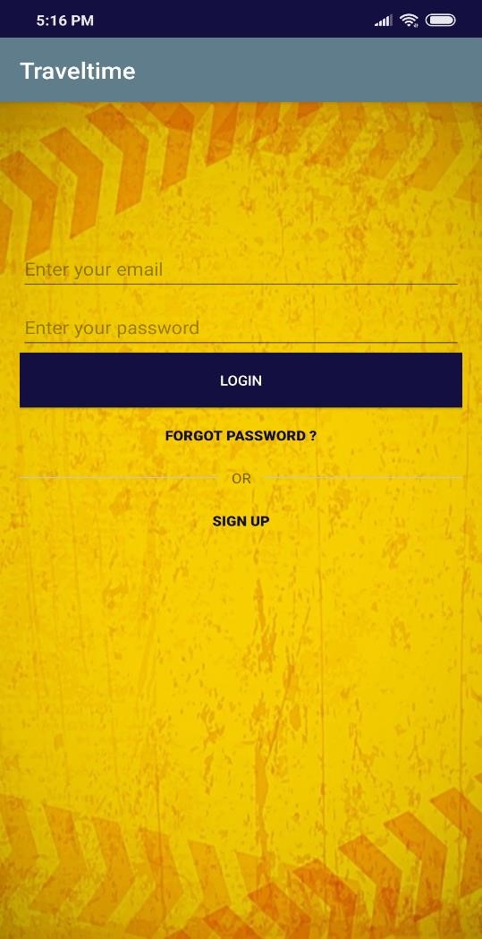

*Figure 12 proto type*

#### 10. End-Project Report

This project is the first android individual application that I have designed. Really it was difficult to handle it. I had to install android studio twice. My laptop was stocked many times. However According to submission steps, project initiation document, interim reports, research and abstract were submitted respectively. Research had covered over the project requirements and to identify requirements in detail research was very helpful. Technical search helped in developing and identifying tools and technologies need to use in the system. Overall project is a great success achieved by me.

##### 10.1 Review of project objectives

My final project was able to achieve most of main objectives of project. I could create a user friendly and perfectly working application according to requirements of clients. It is a nice-looking application with creative interfaces and backgrounds. Travel on time application is very easy to install a new device and very easy to share between 2 devices.

By using this application, admin can include data to the firestore database easily and passengers can retrieve data easily by using passenger application. So, I could achieve 90% of requirements and I think it will enough for this step.

##### 

#### 11. Project Post-Mortem

Travel on time application system was successfully developed and I could achieve my target most of close and stockholders by completing most of targeted objectives. We can achieve and discuss about it after successfully launched this application. It makes some time to achieve to above target.

During the project, I could collect more data from my friends and passengers who travel by bus daily. Some daily travelling people have already selected a specific bus for travelling purposes. Most of them got problem with full payment of bus per month. They can bypass those troubles using this application.

**11.1 Achievements during the development.**

Both applications were built successfully. Requirement testing and user interfaces went very well. There were no any issues during the testing period. Both applications were run perfectly and no bugs and smoothly. Had great feedback from users and I could add more requirements during the testing period too. by these new requirements I could make interfaces of application more attractive and more usable.

Working in an agile manner was very beneficial to the project. Also, it was helped project to remain flexible, which is important in a project of this size with a real-world client. Most importantly this project was developed by a single developer so the agile methodology with sprint technique was very helpful to overcome these issues. It allowed for user stories to be pushed back to the next upcoming Sprint if required, eliminating the rigidity of the waterfall development process for example, which ultimately aided the timely completion of the project.

##### 11.2 Problems faced during the development

* Can’t install android studio correctly. Because of this reason I couldn’t get default suggestions
* Couldn’t connect to firebase correctly
* Not enough time
* Not enough performance of my laptop
* Lack of knowledge about reasons for crashes of android studio emulators

##### 11.3 Future implementations

This application only in an android platform. As a future implementation, I wish to develop travel on time on IOS platform. Then it will very helpful to spread this application among more mobile phone users. I wish to improve this application more creative and user friendly.

Modern travel on time application search buses depending on passenger location and destination. I wish add the date field to this application too. then passenger can filter buses through the date.

I wish to create a web application for this application. Then everyone can use this service of travel on time application on pc or laptop to.

#### 12. Conclusion

Modern world is rapidly developing with technology. People can do lot of things by few taps of his mobile phone. There are two sides of updating of technology. We have to use this technology for wellbeing of human and future world. It makes this world a better place for everyone.

By developing this technology, we can hope a better technology to make life easier. Travel on Time application designed as a solution for modern problems related to public transportation. Agile method and sprint of software development life cycle development was used to design the Travel on Time system with the aid of FireBase and Java language in Android Studios IDE.

This is my first individual android project. So, it was not easy. I faced lot of problems with this application. However, I could finish this project before the deadline successfully. I think this type of project brings us better practically knowledge about software engineering.

**13. References**

#### References

Andolasoft, 2009. *Andolasoft.* [Online] Available at: https://www.andolasoft.com/how-much-does-a-bus-ticket-booking-app-cost/ [Accessed 05 04 2019].

BusBooking.lk, 2012. *BusBooking.lk.* [Online]

Available at: https://www.busbooking.lk/aboutus

[Accessed 04 04 2019].

BusSeat.lk, 2014. *BusSeat.lk.* [Online]

Available at: https://busseat.lk/

[Accessed 05 04 2019].

firebase, 2011. *hackernoon.* [Online]

Available at: https://hackernoon.com/introduction-to-firebase-218a23186cd7

[Accessed 04 04 2019].

google, a. s., 2011. *android studio.* [Online]

Available at: http://www.androiddocs.com/tools/studio/index.html

[Accessed 04 04 2019].

|  |  |  |  |  |
| --- | --- | --- | --- | --- |
| Ltd, e. | (., |  | 2010. | *busticket.lk.* [Online] |
| Available  [Accessed 05 04 2019]. |  | at: |  | https://www.busticket.lk/home |
| XD, a., |  |  | 2017. | *adobe.* [Online] |

Available at: https://www.adobe.com/products/xd/features.html

[Accessed 04 04 2019].

#### 14. Appendices

This travel on time project mainly included 2 separate APKs. Those are passenger’s application and Admins application. To use this project these two applications are very important.

**14.1 Installation and setting up project.**

You need to use 2 android devices to install both of these applications. First copy these APK files to separate devices and install those applications in the devices.

##### Mobile application user manual

After install both of applications you can see this type of login page.

* The start screen you can see the interface below. You can see 2 space to enter your email address and your password. You can see login button and 2 labels below too under the password field.

* To sign up to this application you must provide your email address and a password

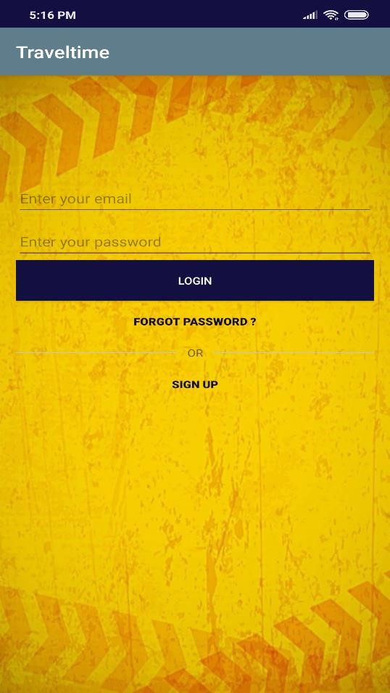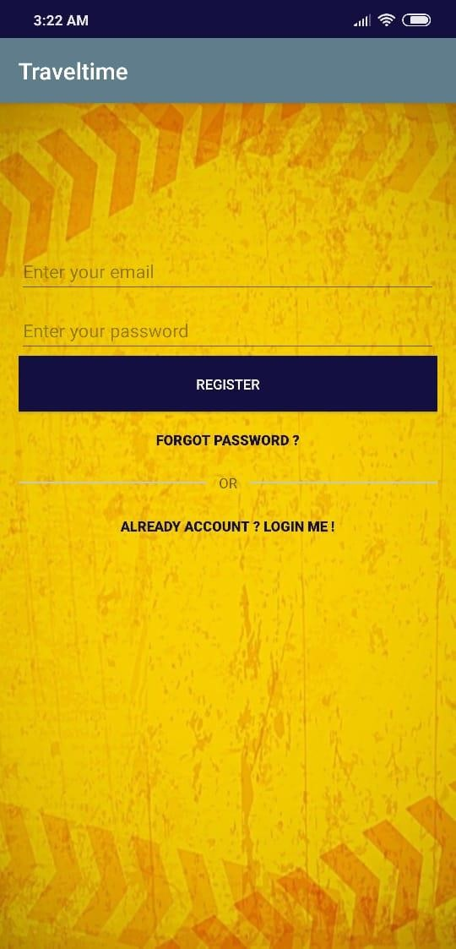

*Figure 13 login*

* After login you can enter to the home screen of application

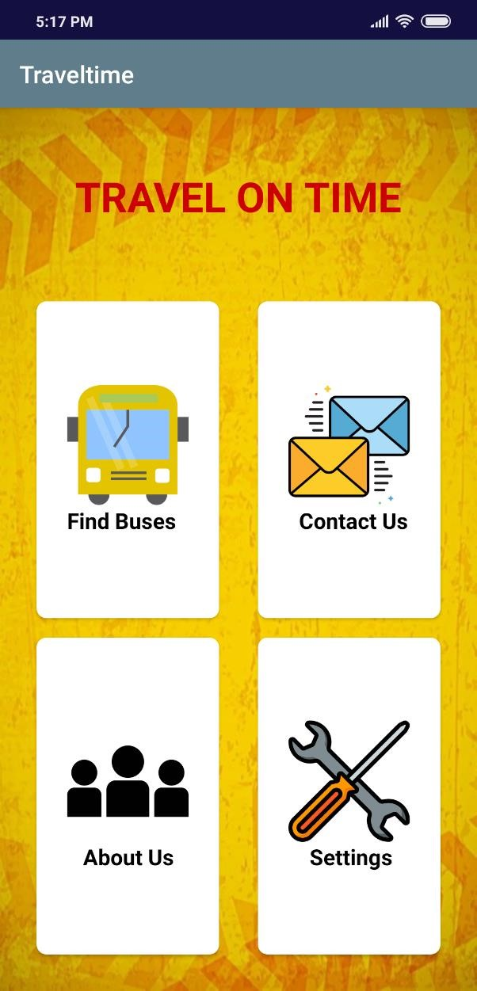

*Figure 16 home*

* If you in the application of admin, you can add details of buses by bi through the add bus. You have to add details of your bus and press save button

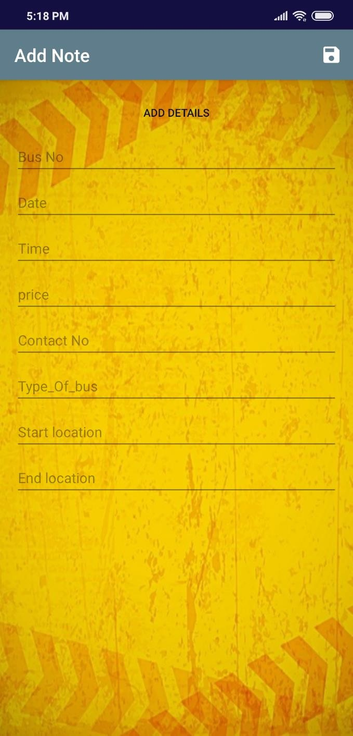

*Figure 17 add data*

When you in passenger application, you can find buses by go through the find bus button. You have to choose your location and destination from the below two drop down menus and press search button.

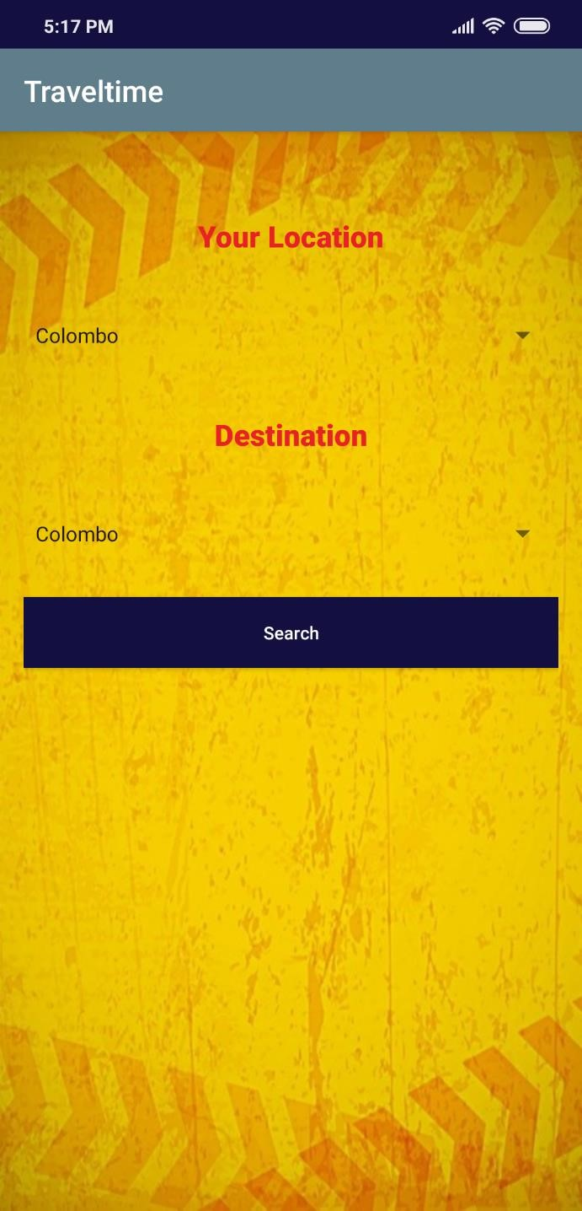

*Figure 18 add location*

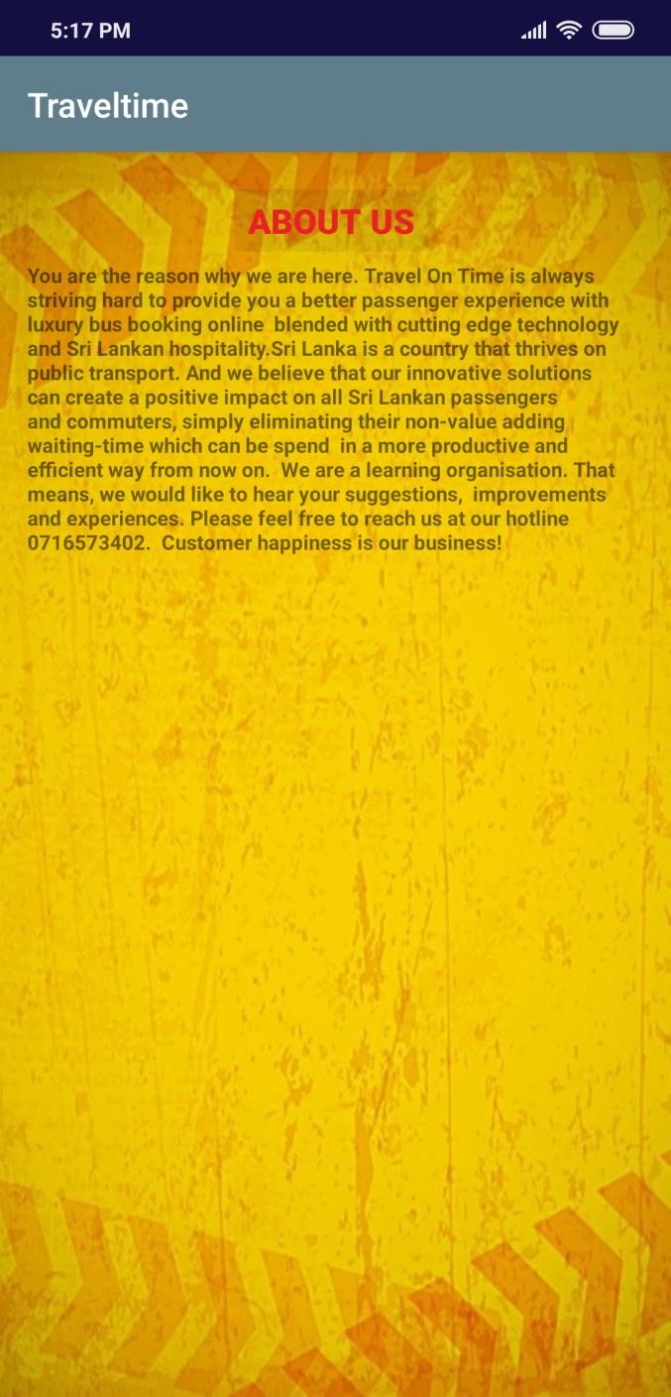

*Figure 20 about us*

* If you want to contact application developers or admins of this project you can select contact us button

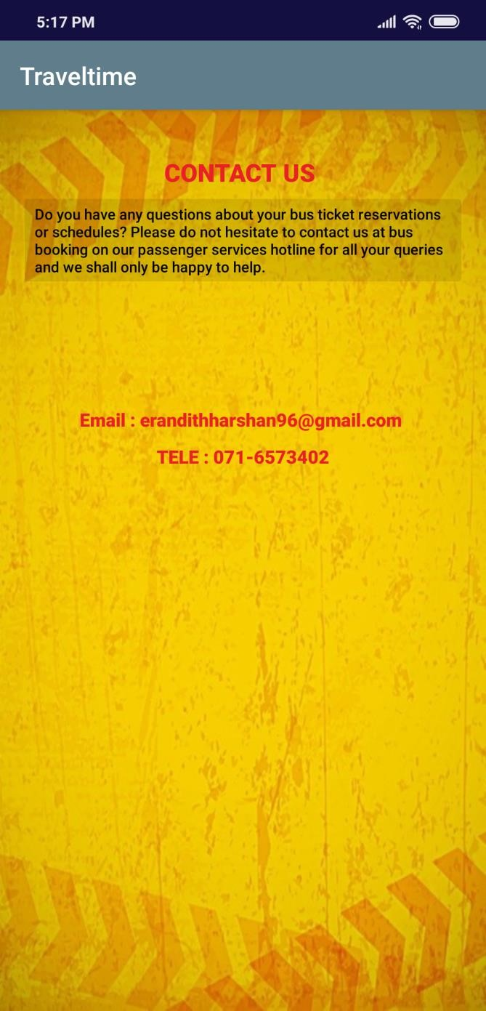

*Figure 21 contact us*

* If you forgot your password you can go through the forgot password and input the email your password.
* Then you will receive an email and you can use URL inside the email to reset your password.

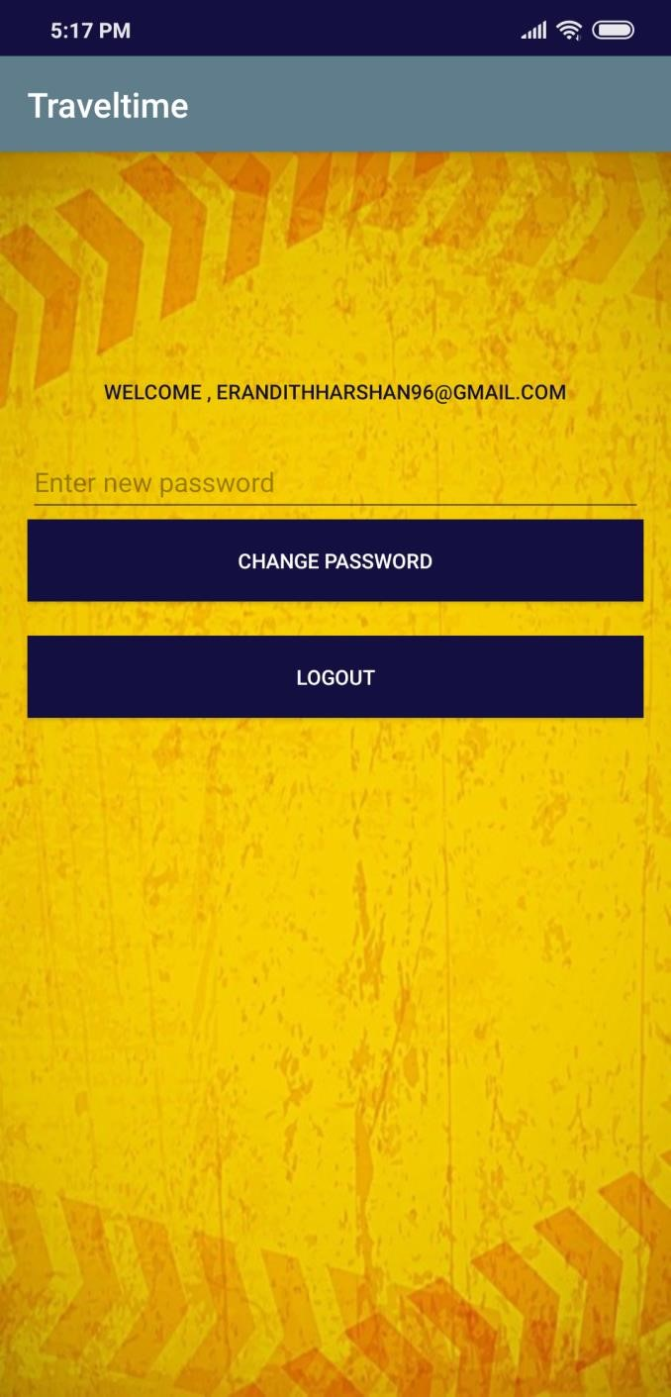

*Figure*

*22*

*change password*